Mandatory Employee Training Tip Sheet

GENERAL INFORMATION 2
HOW TO CHECK IF YOU HAVE COMPLETED EACH MODULE IN CATALOG 2
ONLY APPLIES TO AODA MODULES: HOW TO CHECK IF YOU HAVE COMPLETED THE ENTIRE TRAINING IN CATALOG 3
HOW TO ACCESS TO MODULES (INTERNAL TO ONTARIO TECH) 3
ONLY APPLIES TO AODA MODULES: HOW TO ACCESS TO MODULES (EXTERNAL TO ONTARIO TECH) 4
TROUBLESHOOTING FAQS 6
RECOMMENDED BROWSER 6
THE MODULE FROZE AND I CANNOT RESUME 6
ERROR MESSAGE “YUL.SCORM” 6

GENERAL INFORMATION
- You MUST complete all mandatory training as reasonably practicable but no later than 4 weeks after your start date
- All full-time and limited term employees may be required to complete a refresher course when a module is updated. Check with your supervisor to ensure that your training is up to date.
- It can take up to 1.5 weeks from the date of hire for a new employee to be provided with access to training within Canvas.
- An employee will need an ontariotechu.ca email account to complete training. Speak to your supervisor if you do not have an ontariotechu.ca email account.
- Please note this tip sheet is to assist with troubleshooting and completion of mandatory training modules hosted in CATALOG-Canvas:
  - AODA Training Modules, Preventing Sexual Violence: Building a Respectful Campus Together Module, 4 Seasons of Reconciliation Module and Accessible (AODA) Instruction Training for Educators
    - If you require the training modules content in an alternative format, please email hraccessibility@ontariotechu.ca
- Ensure that you have obtained 100% on all your knowledge checks
- Ensure that you “click and reveal” all content throughout the module(s); and be sure to select “Complete Course” at the end of each module/training
- Completion of the mandatory training modules will be tracked and recorded in CATALOG
- ONLY APPLIES TO AODA MODULES & ACCESSIBLE (AODA) INSTRUCTION TRAINING FOR EDUCATORS: Once you have completed your modules, you will not receive a completion certification, however, your grades will serve as your completion

HOW TO CHECK IF YOU HAVE COMPLETED EACH MODULE IN CATALOG
- Sign in through Ontario Tech Training Modules.
- Access the “Grades” section of the course and review each of the required modules (example image below).
- Please review which modules you are required to complete based on your role at Ontario Tech.
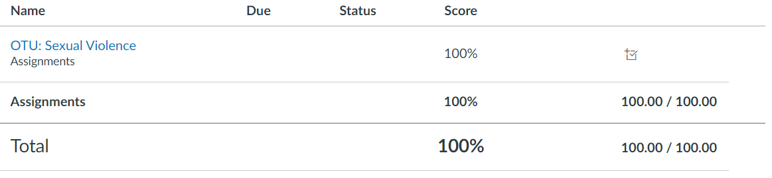
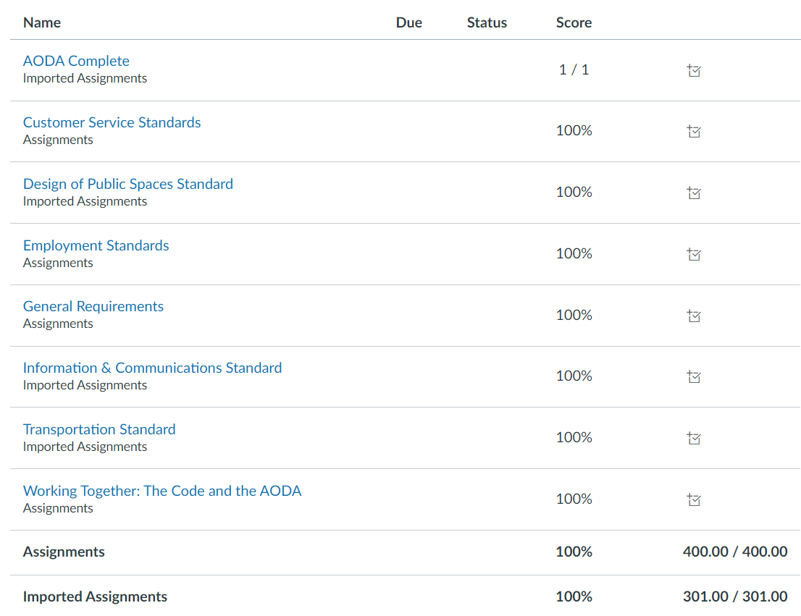
- ONLY APPLIES TO AODA MODULES: If your required modules have a score of less than 100%, they are incomplete, you must return to the home page and complete them.
- If the “Complete Course” button has not shown up, please ensure that you have completed all the knowledge check questions, this includes opening all drop down menus and answering the questions present in each module.
- The complete course button will not appear unless you have completed all the questions.

ONLY APPLIES TO AODA MODULES: HOW TO CHECK IF YOU HAVE COMPLETED THE ENTIRE TRAINING IN CATALOG
- This guidance applies strictly to the AODA Training Modules
- Upon the completion of all modules required based on your role at the university, you will then receive a completion grade (image below)
- This completion grade is done manually, and therefore may take some time to appear within your Grades tab. Please be patient.
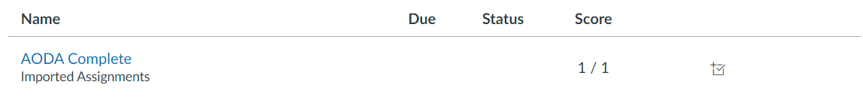

HOW TO ACCESS TO MODULES (INTERNAL TO ONTARIO TECH)
Please use this link to access CATALOG (this is a different version of Canvas than the one used for teaching students). You can access the course by following these steps.
- Navigate to AODA Modules, Preventing Sexual Violence Module, 4 Seasons of Reconciliation or Accessible (AODA) Instruction Training for Educators click “Sign in to Enroll”
- Select the Learn LMS Login or the Staff Login:
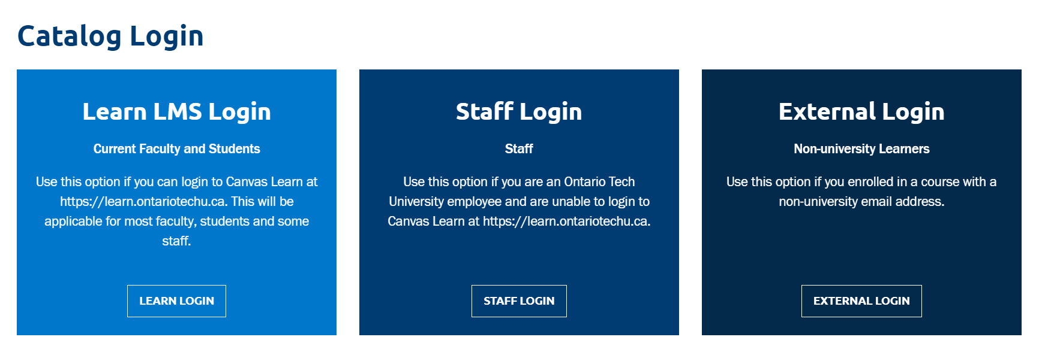
- Sign in using your Banner ID and Password:

ONLY APPLIES AODA MODULES: HOW TO ACCESS TO MODULES (EXTERNAL TO ONTARIO TECH)
NOTE: This is ONLY for those who have NEVER used Canvas or CATALOG at Ontario Tech.
View the Interactive Demo
- Navigate to AODA Modules, Preventing Sexual Violence Module, 4 Seasons of Reconciliation or Accessible (AODA) Instruction Training for Educators click “Sign in to Enroll”
- Select the External Login (far right image below), and use an email address to login, you will need to create a new password.
USE THE SAME EMAIL AND PASSWORD COMBINATION EACH TIME YOU RETURN TO THE TRAINING MODULES. DO NOT CREATE A NEW ACCOUNT.
- Once logged in select “Student Dashboard” from the drop down adjacent to your name and then select ‘Go To Course’ or from Learn select ‘Courses’ from the sidebar and select ‘All Courses”.

TROUBLESHOOTING FAQS
When encountering issues, you can always close the browser window and restart.

RECOMMENDED BROWSER
The recommended browser for training Modules in Canvas is Chrome, please ensure that you have the most recent version.

THE MODULE FROZE AND I CANNOT RESUME
Sometimes when you leave your module idle it will pause. However, instead of pressing “Resume” for each of the modules you should press “Restart” as this will refresh the module and ensure you are able to complete it.

ERROR MESSAGE “YUL.SCORM”
Please refresh the browser and restart the module

Should you continue to encounter issues contact
healthandsafetytraining@ontariotechu.ca

